APPENDIX A

ITS61504

Data Mining

Group Assignment (40%)
Semester April 2026

Name (Block Capital) | Registration No. | Signature | Marks  (For Lecturer Use)
1.Li Zhe | 0370716 | 
2. Liu Yifan | 0374114 | 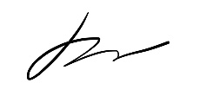
3. Gu Sijia | 0365826 | 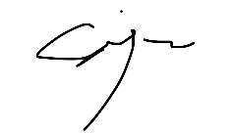

I declare that:
- I understand what is meant by plagiarism
- The implication of plagiarism has been explained to us by our lecturer. This project is all our work, and I have acknowledged any use of the published or unpublished works of other people.



Table of Contents

Contents | Page
1. Introduction and Purpose of Study | 5
2. Description of Data | 6
3. Data Problems and Pre-Processing | 7
3.1 Data Problems Identified | 8
3.2 Pre-Processing Techniques Applied | 8
3.3 Before-and-After Comparison | 11
4. Data Mining Techniques | 13
4.1 Data Mining Techniques Used | 13
4.2 Justification of Selected Techniques | 14
4.3 Implementation of Data Mining Techniques | 15
5. Model Validation | 17
5.1 Validation Approach and Metrics | 17
5.2 Logistic Regression Validation | 18
5.3 Decision Tree Validation | 21
5.4 Random Forest Validation | 23
5.5 Model Comparison and Final Model Selection | 25
6. Conclusion and Future Improvements | 28
7. Python Implementation | 29
7.1 Structured and Documented Python Implementation | 29
7.2 Reproducibility and Clarity of Implementation | 31
8. Real-World Prediction Validation | 32
8.1 England vs Argentina Prediction | 33
8.2 France vs England Prediction | 34
8.3 Spain vs Argentina Prediction | 35
8.4 Comparison with Actual Match Results | 36
References | 37
Appendix A – Assignment Cover Sheet | 1
Appendix B – Individual Tasks Allocation | 3
Appendix C – Assignment Assessment Rubric | 40

1.Introduction and Purpose of Study
The FIFA World Cup is one of the most popular sporting events in the world and receives attention from the world's football associations, media, analysts and so on. To illustrate, FIFA has stated that the Qatar 2022 World Cup reached approximately five billion fans through television, digital platforms, social media, and other channels (FIFA, 2023). Given this huge public and business interest, making predictions about the outcome of football games has become a major football analytics problem. However, football is difficult to predict because many factors can influence the outcome of a match.
This project addresses the main problem of using the data of the previous international football games to predict the outcome of future FIFA World Cup games. This project does not attempt to predict the final score of each match, but instead classifies the result of each match into one of three classes: home win, draw and away win. This is more realistic, as the actual score is sometimes hard to predict, but very valuable and measurable learning can be gained from the classification of the outcomes. This project uses data from the Kaggle dataset International Football Results, which provided structured data on football games played by men's international teams from 1872 to 2026, including match date, teams, scores, tournament, city, country, and if the match was played at a neutral venue (Jürisoo, 2026).
The reason behind using data mining is that the data set consists of a vast amount of historical match records which can be converted to useful patterns and predictive features. For instance, using historical data, the recent form of a team, average goals scored, average goals conceded and the difference in performance between the two teams can be calculated. Such features can then be employed in machine learning models to discover relationships and match outcomes. The results indicate that the machine learning model can be used to predict the result of football matches as in the previous studies, depending on the data gathered from previous matches and the teams' performance (Beal et al., 2020; Al-Bustami & Ghazal, 2025).
This project is motivated from practical as well as research aspects. The model can be used to help analyse sports by providing a more data-driven perspective of potential World Cup outcomes from a practical point of view. Research wise the project will enable the team to implement the entire data mining process that involves data preparation, feature engineering, modeling for classification and model evaluation. The model is not intended to guarantee exact football results. Instead, it provides a structured predictive modelling process that discovers useful patterns in international football data and evaluates how well machine learning can classify World Cup-related match outcomes.

2.Description of Data
The dataset acquired for this project is the International Football Results from 1872 to 2026 dataset from Kaggle. It includes the records of the men’s international football matches including those played in the FIFA World Cup, friendly matches, qualification matches, and other international tournaments. This data set is appropriate to the project since it gives a much bigger historical data set than World Cup matches alone. In the case of this project, which aims to predict the outcome of World Cup matches, a larger data set of international matches can be used to learn about the general patterns of football performance, which can then be applied to the World Cup context (Jürisoo, 2026).
The data is stored in a table in a structured format, as a CSV file. The data in the uploaded results.csv file has 49,477 rows and 9 columns. Each row is an international football match and each column represents one aspect of that football match. The matches cover a long historical time period, from 30 November 1872 to 27 June 2026. In the latest rows, some World Cup 2026 matches are not scored yet and some of the cells in the "score" columns are blank. Hence, only finished matches with scores will be considered for training and testing the model.
The important features of the data set are date, home_team, away_team, home_score, away_score, tournament, city, country, and neutral. The date column is significant because it is required to have the data in chronological order when creating historical performance features. The home_team and away_team fields specify the two teams that played each game and the home_score and away_score fields are used to form the target field. If the home team's score is greater than the away team's score, the result is considered a home victory; if the scores are equal, it is a draw; if the away team's score is greater, it is an away victory. The tournament column is used to distinguish FIFA World Cup matches from friendly matches, qualification matches, and other competitions. The city, country and neutral columns provide venue related information, such as if the match was played at a neutral venue.
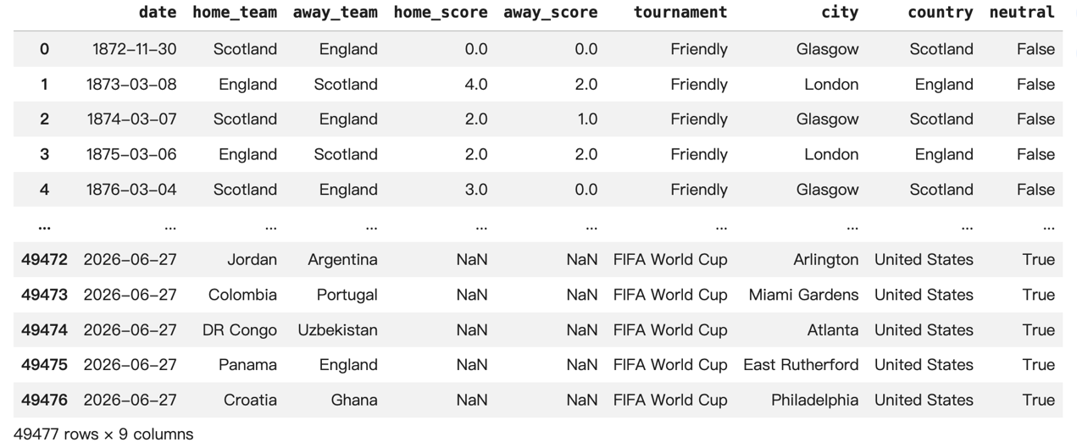Figure 1. Representative sample of the International Football Results dataset
A representative sample of the data set is shown in figure 1. The first few rows display early friendly games between Scotland and England, and the last few rows contain scheduled FIFA World Cup matches in 2026 with missing scores. This sample represents the key features of the data set, including historical match data, team names, final scores, type of competition, venue location, and neutral venue data. It also demonstrates one practical problem in the data: future (unplayed) matches must be removed from the data before modelling since the results are not known.

3. Data Problems and Pre-Processing
3.1 Data Problems Identified
Before model development, an initial data audit was conducted to identify potential data quality problems in the international football match dataset. Several issues were identified that could negatively affect the reliability of the machine learning models.
Firstly, the data is missing, especially scores of home and away teams. The majority of these scores were for future games or incomplete matches. The actual result of the matches was not known, and could not therefore be used as labelled training samples. Secondly, duplicated match records were checked since duplicated observations would lead to the same match being used more than once and to an unnecessary bias of the model.
Thirdly, the date attribute was not in a proper datetime format. Football matches are observations that are time dependent; thus, if they are not in chronological order, future observations could be used inadvertently to produce historical features.
Another problem was the number of various tournament names in the original data set. Each specific tournament name would be a categorical feature which could number of categories and would complicate the model.
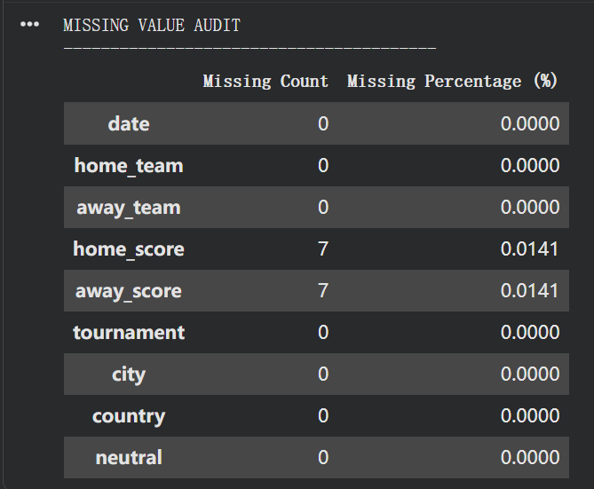
Last but not least, the raw data is primarily composed of fundamental match data like teams, scores, tournament and venue. The raw attributes themselves are not an accurate measurement of the past history and recent performance of each nation's team. Thus more historic features were needed prior to the training of the model.

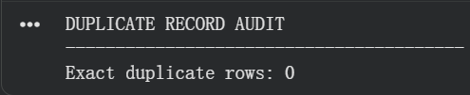
Fig3.1
3.2 Pre-Processing Techniques Applied
The problems identified were solved by several data preprocessing and transformation techniques, which were done to prepare the dataset for machine learning.
Data Cleaning
All matches were first converted to the Pandas datetime format, and then sorted by date. After that, duplicate records were eliminated.
The matches where there are no home_score or away_score fields were isolated from matches in the past that are considered completed. Only complete matches were used to build the labelled modelling dataset as the final result should be known to decide the target class.
The cleaned dataset was then reset and chronologically sorted to give a solid basis for historical feature engineering.
Target Variable Transformation
The classification target is not directly provided in the original dataset, but represents the final match outcome. So to create a new target variable, a comparison of home and away scores created a new variable called result.
Every successfully completed match became a member of one of three classes:
- Home Win
- Draw
- Home Loss
The initial dataset of the football game was changed to become a supervised multi-class classification problem.
Historical Feature Engineering
The original data include match level data but do not directly accurately reflect each team's historical strength. So, historical performances were generated based on the past matches of each team.
Main historic elements consisted of:
- Recent win rate
- Recent draw rate
- Average goals scored
- Average goals conceded
- Recent goal difference
- Historical match experience
The recent-performance statistics were derived from the top five games played by the team just recently, so the model will reflect the teams' form at the moment instead of using a long-term historical approach.
To avoid temporal data leakage, an explicit chronological process was established. Historical features were determined prior to adding the results of matches to team history for matches played on the same date. Thus, the model was not able to 'learn' information that would have been unavailable prior to a match.
In the case of teams with not enough historical data, their overall average statistics were used as a default if they didn't have enough historical data to address the cold start problem.
Feature Transformation
Other relative-strength features were created by looking at the past statistics for each of the two teams that played against each other:
- Win rate difference
- Goal difference difference
- Experience difference
These attributes directly reflect the difference in performance between the home team and the away team and give a greater indication of the information that should be used for classification.
The tournament names were also categorized into a few more general categories:
- World Cup
- Qualification
- Friendly
- Other Competitive
One-hot encoding was subsequently applied to these tournament categories. The neutral attribute was converted into a binary numerical feature.
Feature normalisation was not universally required because Decision Tree and Random Forest models are not sensitive to feature scale. However, StandardScaler was specifically applied to Logistic Regression, where feature scaling is important because the numerical variables have different ranges.
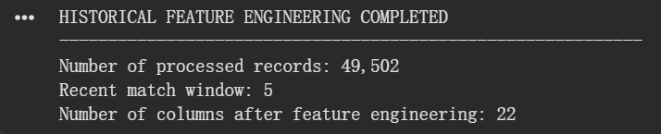
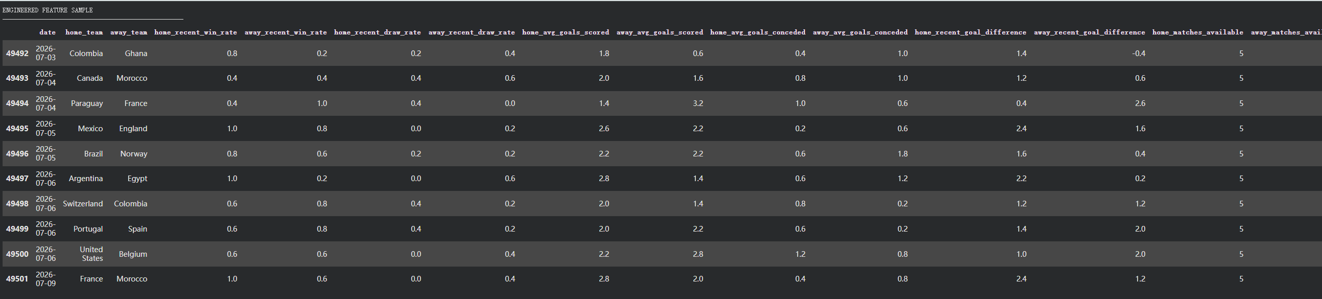
Fig3.2

3.3 Before-and-After Comparison
The pre-processing procedure considerably altered the raw football match data into a machine learning modeling dataset which is structured into a format.
The raw data had information on matches, future matches might not have been recorded, duplicate observations appeared in the data, many individual tournament categories and there was no direct representation of historical team performance.
Only valid completed historical matches were used for model development after the preprocessing. Dates were uniformized and sorted in chronological order, duplicate observations were discarded, the prediction target was created, the tournament data was simplified and encoded, and years of team performance data were added.
The main improvements are summarised in Table 3.1.

Table 3.1. Comparison Before and After Data Pre-Processing
Data Aspect | Before Pre-Processing | After Pre-Processing
Match scores | Included records with missing scores | Completed matches retained for modelling
Duplicate records | Potential duplicate observations | Duplicate records removed
Date | Raw date representation | Converted to datetime and chronologically sorted
Target variable | No explicit prediction target | Home Win, Draw and Home Loss
Team strength | Not directly represented | Historical performance statistics generated
Recent performance | Not available | Recent five-match statistics generated
New-team records | Limited/no historical information | Cold-start values replaced using overall averages
Tournament | Numerous tournament names | Grouped into four categories and one-hot encoded
Relative team strength | Not available | Difference features generated
Neutral venue | Original categorical/Boolean representation | Binary numerical representation
Temporal leakage | Possible if historical features are incorrectly generated | Chronological feature generation prevents future information leakage

In the preprocessing stage, thus, the data were made more consistent and the original dataset, consisting of raw football match data, was converted to a machine-learning-ready dataset with historical, contextual and relative-strength information.
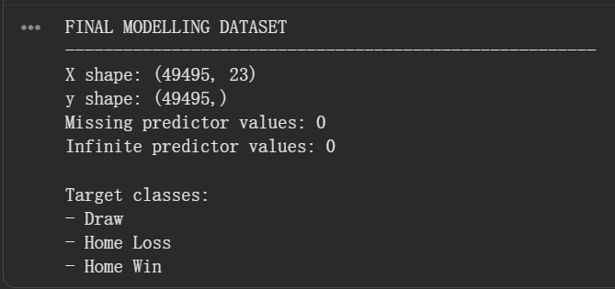
Fig3.3

4. Data Mining Techniques
4.1 Data Mining Techniques Used
The primary data mining technique applied in this project was supervised classification, because the objective was to predict a discrete football match outcome based on historical match information.
The target variable consists of three possible classes:
- Home Win
- Draw
- Home Loss
To compare different classification approaches, three machine learning algorithms were implemented:
- Logistic Regression
- Decision Tree
- Random Forest
Logistic Regression was used as a linear baseline model, while Decision Tree and Random Forest were introduced to capture more complex and nonlinear relationships between historical team-performance variables and match outcomes.
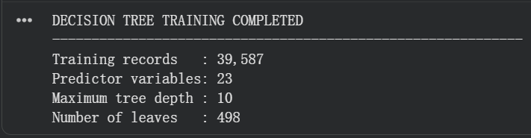
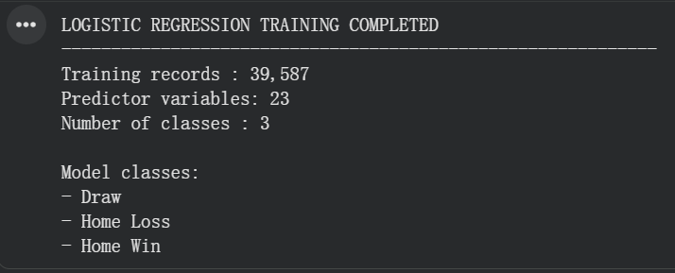
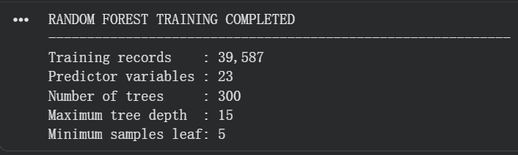

Fig4.1

4.2 Justification of Selected Techniques
Classification was selected because the objective of the project is to assign each football match to one of three predefined outcome classes rather than discovering unknown groups or associations. Therefore, classification is more appropriate than techniques such as clustering or association-rule mining.
Logistic Regression was chosen as a baseline model due to its efficiency and widespread use as a classification model. Its performance will provide a guideline for judging the value of more complicated nonlinear algorithms.
Decision Tree was chosen as it is suitable for situations where there are multiple variables like recent win percentage, goal difference, team experience, tournament conditions, etc., and they can have nonlinear relationships. These relationships can be captured without normalising features and can be captured as interpretable decision structures in Decision Trees.
Random Forest was chosen as an ensemble method to replace Decision Tree. Random Forest can be used to combine the prediction abilities of various decision trees, thereby reducing the variance of a single decision tree, and supplying extra information by conducting feature importance analysis.
The three approaches thus enabled the project to evaluate the performance of a linear baseline model, an interpretable nonlinear model and an ensemble tree-based model under identical experimental conditions.
4.3 Implementation of Data Mining Techniques
The same chronologically prepared modelling dataset was used for training all three classification models. To avoid randomizing historical matches, the first approximately 80% was used in the training set, and the last 20% was used in the testing set.
This chronological splitting strategy is similar to a realistic scenario in a football prediction except that historical information is applied to predict matches that come later.
Logistic Regression
The numerical features were standardised with StandardScaler before being used in Logistic Regression. The classifier was then trained using the scaled training set and tested in the testing set to predict the outcome of the match: win, draw or lose. Sufficient iterations were set for the model to converge while training.
Decision Tree
As tree-based classifiers do not require features to be scaled, the Decision Tree was trained directly on the engineered feature set.
The complexity of the tree was controlled using maximum tree depth, minimum samples per leaf, and minimum samples needed for splitting to prevent over growth of the tree and enhance generalisation. The trained tree was also visualised to show the contribution of the different features to the classification decisions over time.
Random Forest
Random Forest classifier is an ensemble of 300 Decision Trees. To prevent the model from becoming too complex, maximum tree depth and minimum number of samples were controlled.
Additionally, the model computed the importance of the features, which were then utilized to determine the features that most significantly influenced the prediction of football matches. After the models have been developed, they are compared and the best one is selected.
All three models were then trained and used to predict on a chronological testing set. They were judged on the following points in their performances:
- Accuracy
- Precision
- Recall
- Macro F1-Score
Aside from the evaluation of all the matches played in the international tournament during the testing period, a special evaluation was carried out for the FIFA World Cup tournament.
The main criterion to select the final model was the FIFA World Cup Macro F1-Score, since the main objective of this project is to predict the FIFA World Cup.
The best Macro F1 score on the FIFA World Cup subset was obtained by the Decision Tree model. Hence, Decision Tree was chosen as the final prediction model.
The selected Decision Tree was then retrained with all available completed matches for the final interactive prediction system to be able to use as much historical information as possible.
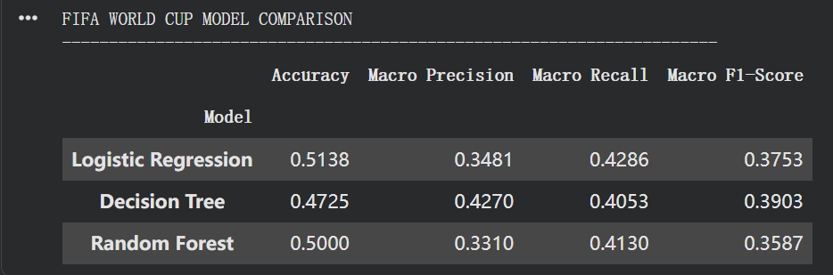
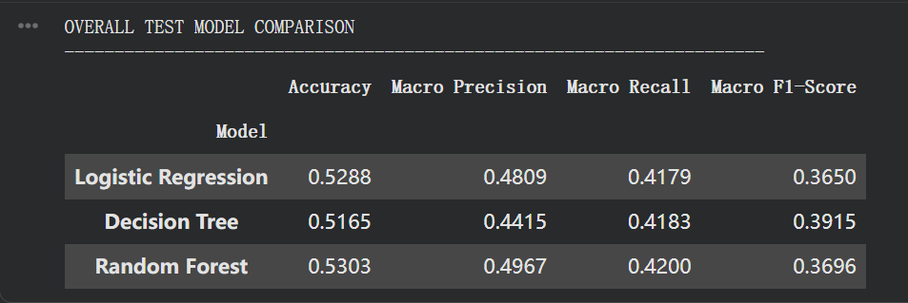
Fig4.3

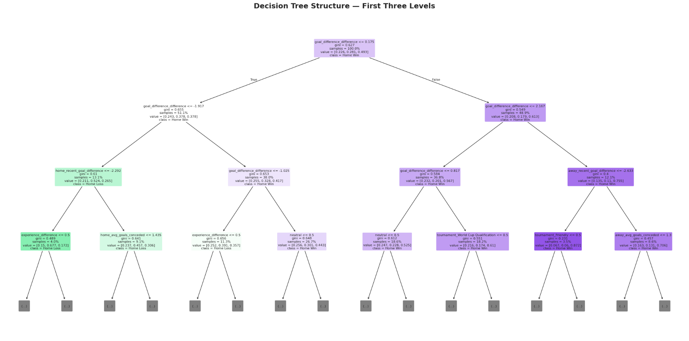
Fig decision tree

5.0 Model validation
Model validation was performed to assess predictive capability of machine learning models formulated in the FIFA World Cup match prediction task. The three supervised classification models compared in this project were: Logistic Regression, Decision Tree and Random Forest. Target variable was based based on three categories: Draw, Home Loss or Home Win.
5.1 Validation Approach and Metrics
The dataset was tested with a chronological train-test split with 80% of match record history used for training and 20% used for testing.
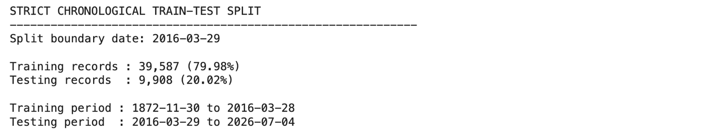
The choice of a chronological split was made as the prediction task in football is time sensitive. This way, the models are trained with previous match data and tested on subsequent matches, more resembling a real-world prediction scenario. It also helps to reduce accidental time data leakage when training models.
The accuracy, macro-precision, macro-recall and macro-F1 score were all calculated to measure the performance of the model. Accuracy represents the percentage of correct predictions of matches. The three outcome classes, however, are not equally represented and some outcomes, such as Draw, are more challenging to foresee the outcome. Macro precision, macro recall and macro F1-score were also included since they measure the model's performance equally for all classes. Confusion matrices were also used to find out the classification number of each model with Draw, Home Loss and Home Win.

5.2 Logistic Regression Validation
Logistic Regression was the first model evaluated in this project. Based on the overall test set,
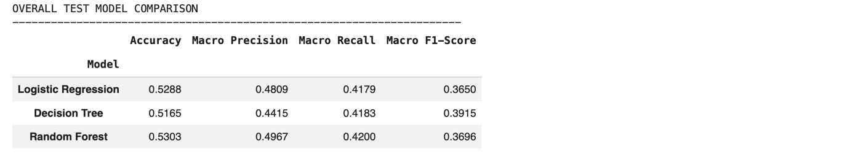
Logistic Regression performed an accuracy of 0.5288, macro precision of 0.4809, macro recall of 0.4179, and macro F1-score of 0.3650. This indicates that the model has correctly predicted the outcomes of a bit over half of all matches.
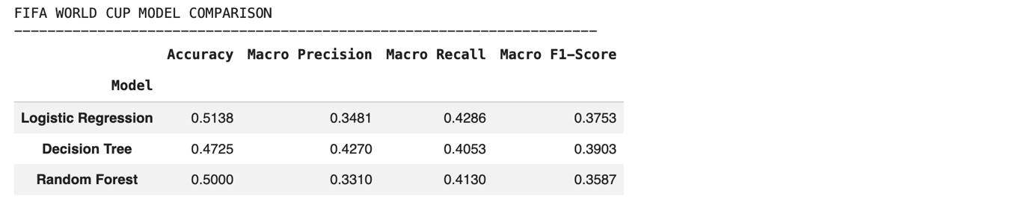
In the case of the test subset used for the FIFA World Cup, Logistic Regression had the highest overall accuracy at 0.5138. Its macro precision was 0.3481, macro recall was 0.4286, and macro F1-score was 0.3753. This suggests Logistic Regression did a fairly good job with World Cup matches on overall predictions.
The overall performance of the classes reveals that Logistic Regression was not able to recognize the results of Draw.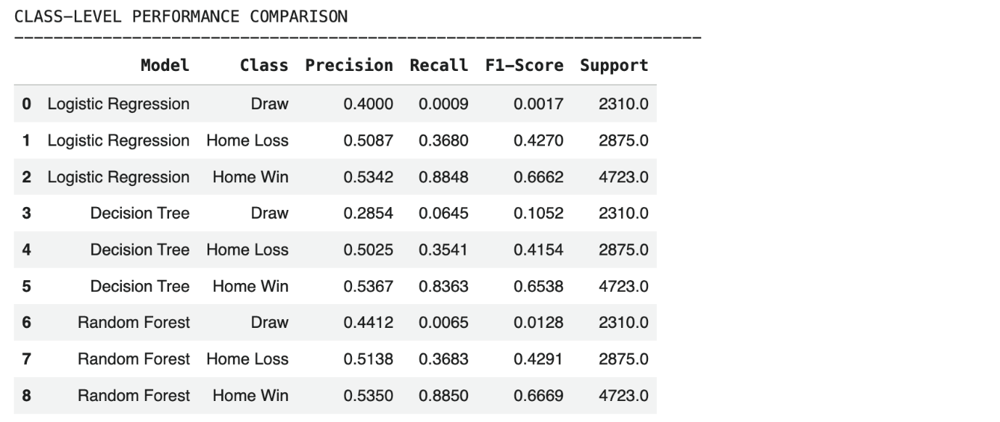
For the overall test set, the F1 score for Draw was only 0.0017 whereas the F1 score for Home Win was much higher at 0.6663. That is, the model to predict Home Win was far superior to Draw Win.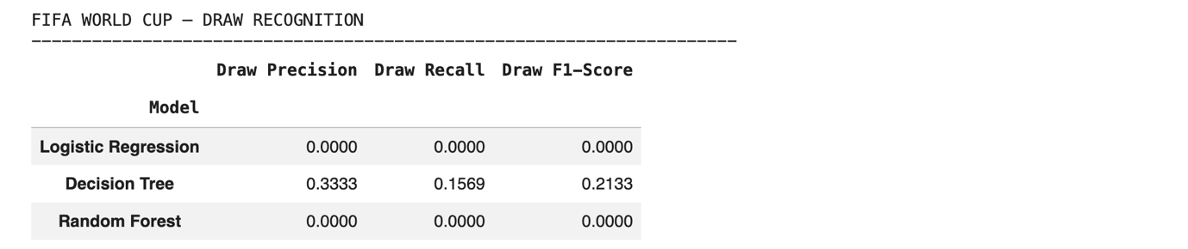
With respect to the FIFA World Cup subset, Logistic Regression did not perform a substantial World Cup draw precision or recall and its F1-score was 0.0000.
However, despite achieving the highest overall accuracy on the FIFA World Cup subset, Logistic Regression failed to recognise Draw outcomes, with a Draw F1-score of 0.0000. Therefore, it was not selected as the final model because its performance was highly unbalanced across the three outcome classes.
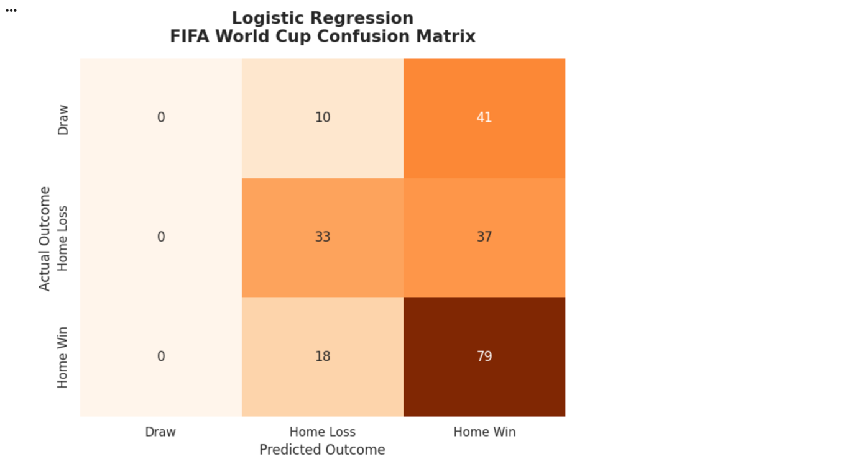

5.3 Decision Tree Validation
Decision Tree was the second model evaluated. On the overall test set,
Decision Tree reached an accuracy of 0.5165, macro precision of 0.4415, macro recall of 0.4183 and macro F1-score of 0.3915. In terms of macro F1 score among the three models, its accuracy was slightly lesser than Logistic Regression and Random Forest but the best.
On FIFA World Cup test subset, Decision Tree's accuracy score was 0.4725, macro precision of 0.4270, macro recall of 0.4053, and macro F1-score of 0.3903. This was the best World Cup macro F1-score for the 3 models. This outcome indicates that the Decision Tree was most balanced.
In the overall test set, its Draw recall was 0.0645 and Draw F1-score was 0.1052.
Decision Tree outperform the other models in Draw outcome recognition. Decision Tree performed better with a Draw precision of 0.3333, a Draw recall of 0.1569 and a Draw F1-score of 0.2133. While these are not yet high, it was the only model that was able to recognise drawn World Cup games in any way. This is significant because Draw is one of the most difficult sporting events to forecast in football odds.
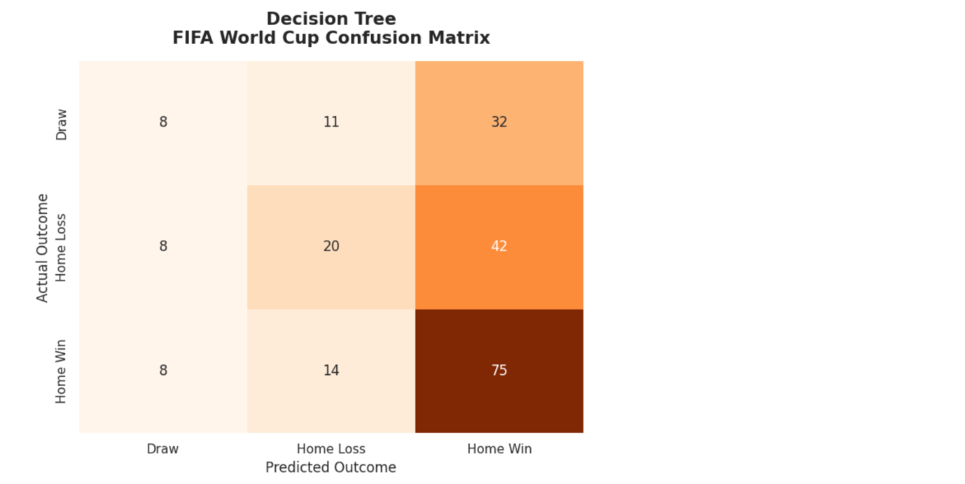

5.4 Random Forest Validation
Random Forest was the third model evaluated. On the overall test set,
Random Forest has overall accuracy of 0.5303. It also gained the macro precision 0.4967, macro recall 0.4200 and macro F1-score 0.3696. As it is seen this is the best overall accuracy and macro precision of the Random Forest.
For the FIFA World Cup test subset,
Random Forest had an accuracy of 0.5000, macro-precision of 0.3310, macro-recall of 0.4130, and macro-F1 of 0.3587. The model made satisfactory accuracy but its macro F1 score is lower than the scores of Decision Tree and Logistic Regression. This implies that Random Forest is not the most balanced between the three outcome classes.
Class-level results indicate that Home Win has been successfully predicted by Random Forest with a Home Win F1-Score of 0.6669. Just like Logistic Regression, however, was not very good at recognizing Draw outcomes. Its overall Draw F1-score was just 0.0128, and on the subset FIFA World,
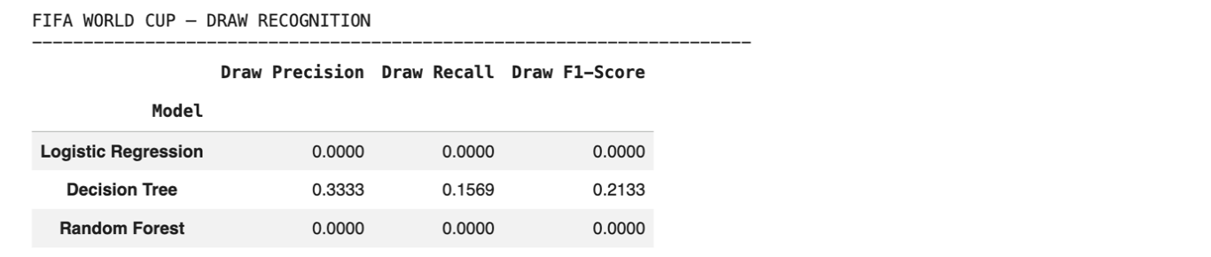
the precision and recall both equaled 0.0000 and the F1 score was also 0.0000. This indicates that while the overall accuracy of Random Forest was better, it did not work well for drawn World Cup matches.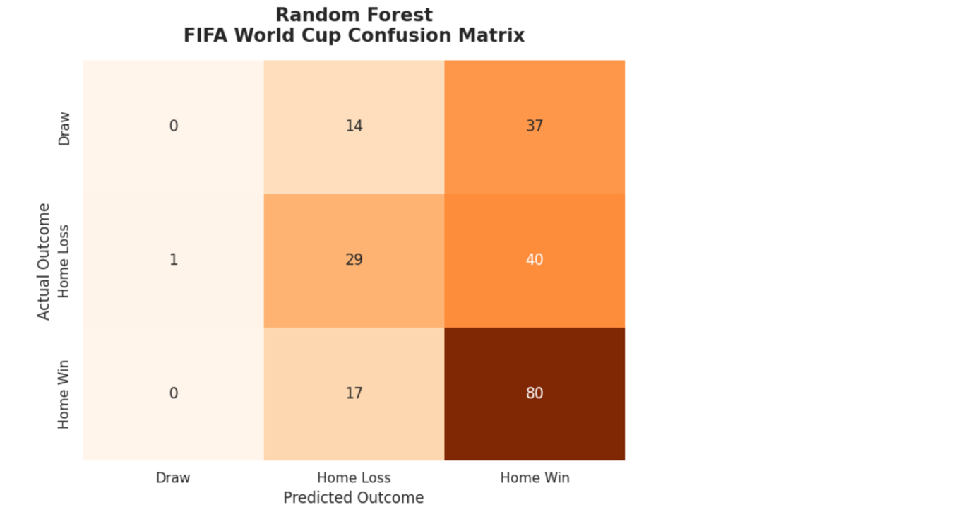

5.5 Model Comparison and Final Model Selection
The model comparison results show that each model had different strengths.
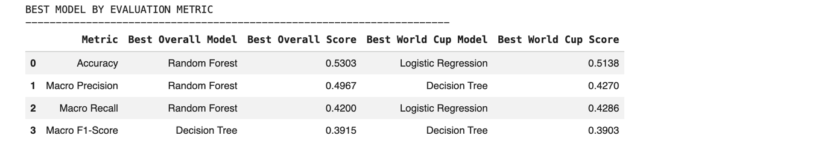 Random Forest showed the best overall accuracy with 0.5303 and Logistic Regression obtained the best FIFA World Cup accuracy of 0.5138. Decision Tree however, had the best overall macro F1-score of 0.3915 and the best FIFA World Cup macro F1-score of 0.3903.
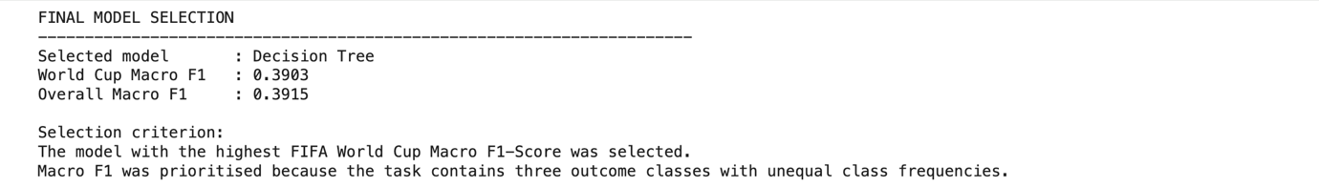
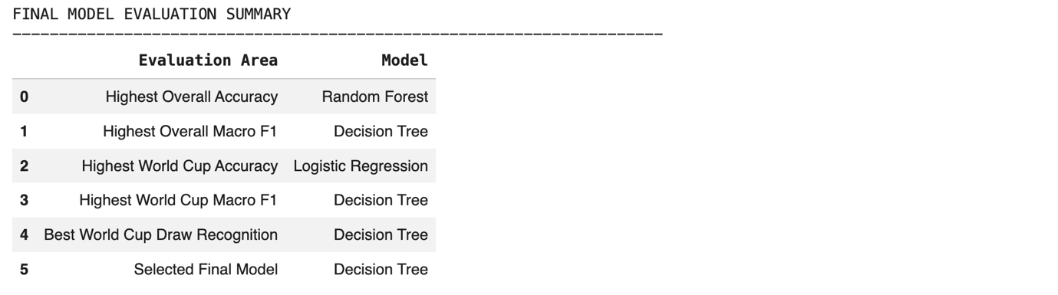
The maximization of macro F1 score over accuracy is used to this project, as the prediction task is based on three outcome classes with unequal distribution. While the model might be more accurate, it might predict the dominant class quite well with inadequate performance on more challenging classes like Draw. Since Decision Tree provided the best macro F1-score and showed the strongest draw recognition performance, it was selected as the final model for FIFA World Cup match prediction.
In general, the results of the validation showed that football match prediction is a multi-class classification problem. All three models performed moderately; however, none of them predicted highly precisely in all outcome classes. This suggests that additional features, improved model tuning, and more advanced modelling techniques may be needed to improve future prediction performance.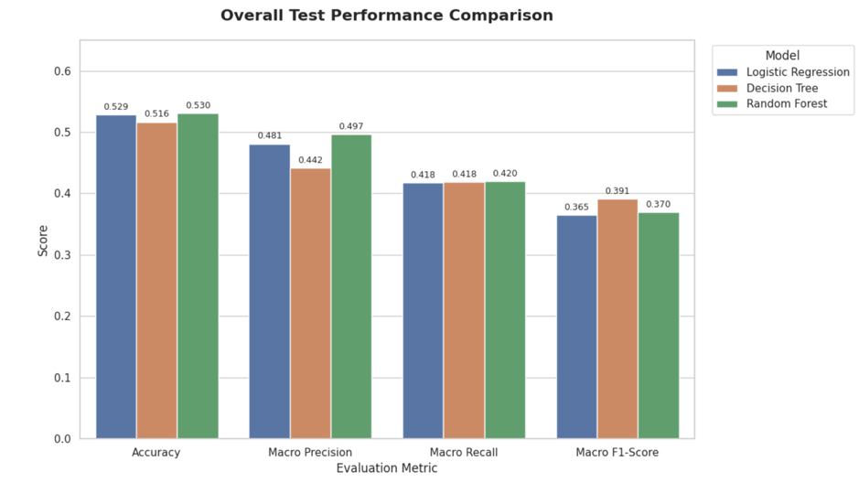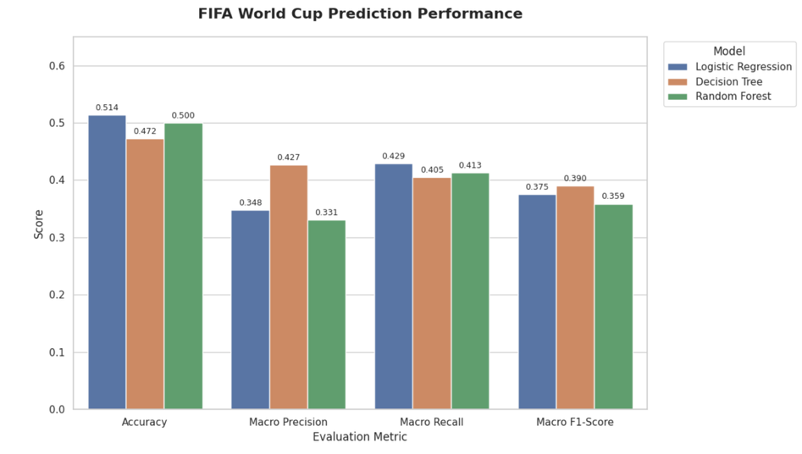
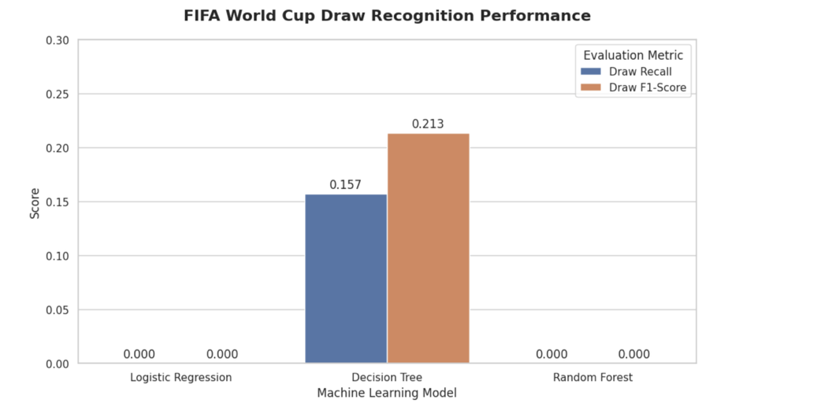

6.0 Conclusion and Future Improvements

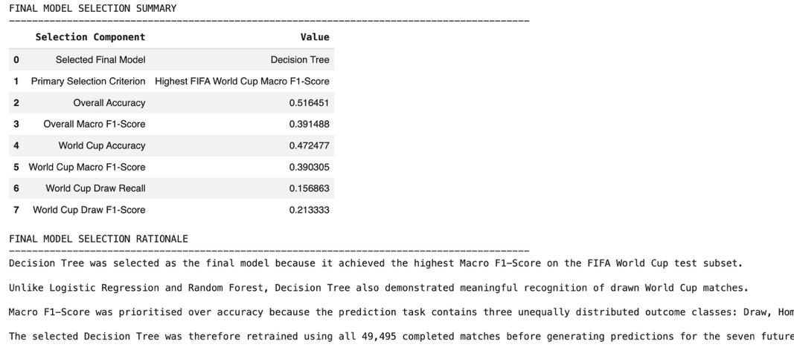
The outcome prediction for FIFA World Cups using a historical dataset of international football matches was successfully developed using a predictive modelling framework. The final modelling data comprised 49,495 completed match records and 23 variables were used to fit and test the models. These predictors were recent performance features, historical experience, team differences, match context, and tournament category features.
Three classification models were implemented: Logistic Regression, Decision Tree, and Random Forest. The results revealed that none of them had high prediction accuracy, illustrating the complexity of predicting outcomes in football match. There are numerous unpredictable factors that go into football results, including team tactics, player health, injuries, match pressure, and unforeseen events during the game. So, a 50% accuracy rate is fair for this type of exercise, considering that Draw, Home Loss, and Home Win are all three outcomes.
The best overall accuracy score of the three models was the Random Forest and highest accuracy score on the FIFA test subset was Logistic Regression. Nevertheless, Decision Tree was chosen as the final model as it obtained the highest FIFA World Cup macro F1-score and the strongest capability to recognize drawn matches. This is significant as the accuracy could potentially mislead if the model does well on the majority classes and not as well on less common or more challenging predictions. The models were compared fairly across all three match outcome classes by using macro F1-score.
Results indicate that historical performance measures and team comparisons can be of help in the prediction of match outcomes. The results demonstrate, however, that predicting football results is still a very complex challenge. The relatively low macro F1-scores show that the models did not perform well in all outcome categories, especially the draw outcomes. This can be due to class imbalance, limited feature representation, or the variability of football games.
For future improvements, several steps can be considered：
- Additional features could be included, such as FIFA ranking, player injuries, team line-ups, recent squad strength, coach changes, betting odds, and match location details.
- Hyperparameter tuning using Grid Search or Random Search could be applied to improve model performance.
- More advanced models such as Gradient Boosting, XGBoost, or ensemble stacking could be tested. Fourth, class imbalance handling techniques could be applied to improve the prediction of difficult classes such as Draw.
- Cross-validation or rolling-window validation could be used to further improve the reliability of the model evaluation.
The project exemplifies the potential applications of data mining and machine learning algorithms in enhancing football match prediction. While the predictive power is constrained, the analysis offers valuable insights into model comparison, feature importance, and the challenges associated with multi-class sports prediction.

7. Python Implementation
7.1 Structured and Documented Python Implementation
This unit will also cover how to write code in Python using a structured approach and how to document the code.
The entire data mining process was performed in Python on Google Colab. The process of implementation was broken down into easily identifiable steps: Data Loading, Data Auditing, Preprocessing, Feature Engineering, Model Training, Evaluation, Visualisation, and Match Prediction. This modular design allows the source code to be more easily understood, maintained and run.
The primary libraries used in Python for implementing these tools were Pandas and NumPy, both for data manipulation and numerical processing; Scikit-learn for data pre-processing, machine learning and model evaluation; and Matplotlib for visualising results.
The first thing that was done in the pre-processing implementation is to convert the date attribute to date-time, and then sort all the matches chronologically. Matches in the past were distinguished from matches in the future and completed matches from incomplete matches were removed, and duplicate observations were removed. A target variable was then created that was three classes: Home Win, Draw, and Home Loss.
Special functions were created to perform historical feature engineering to compute team performance statistics from previous games. These contained recent win rate, draw rate, average goals scored and conceded, goal difference and historical match experience. Other relative-strength numbers were developed by comparing the statistics of the home and away teams.
Categorical tournament data was then transformed into one-hot encoded categorical data, and the neutral venue indicator was one-hot encoded into numeric data. This feature matrix was then used for training and testing Logistic Regression, Decision Tree and Random Forest classifiers.
Comments, section headings, descriptive variable names, and reusable functions were used to extensively document the implementation. It is a structured approach so that each part of the data mining pipeline can be easily distinguished and understood from the source code.

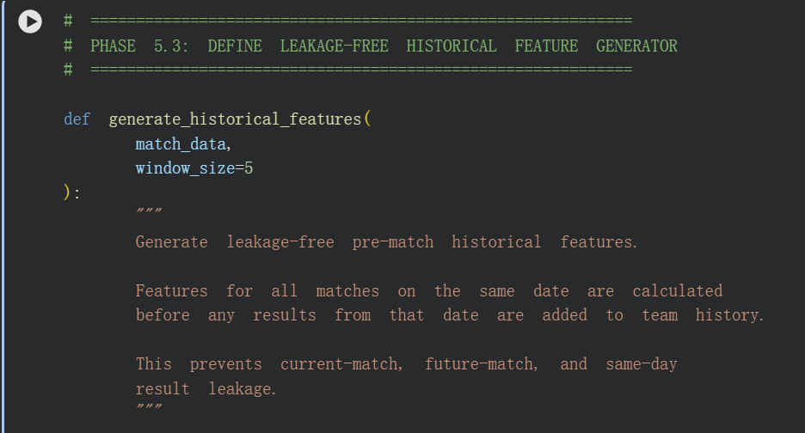

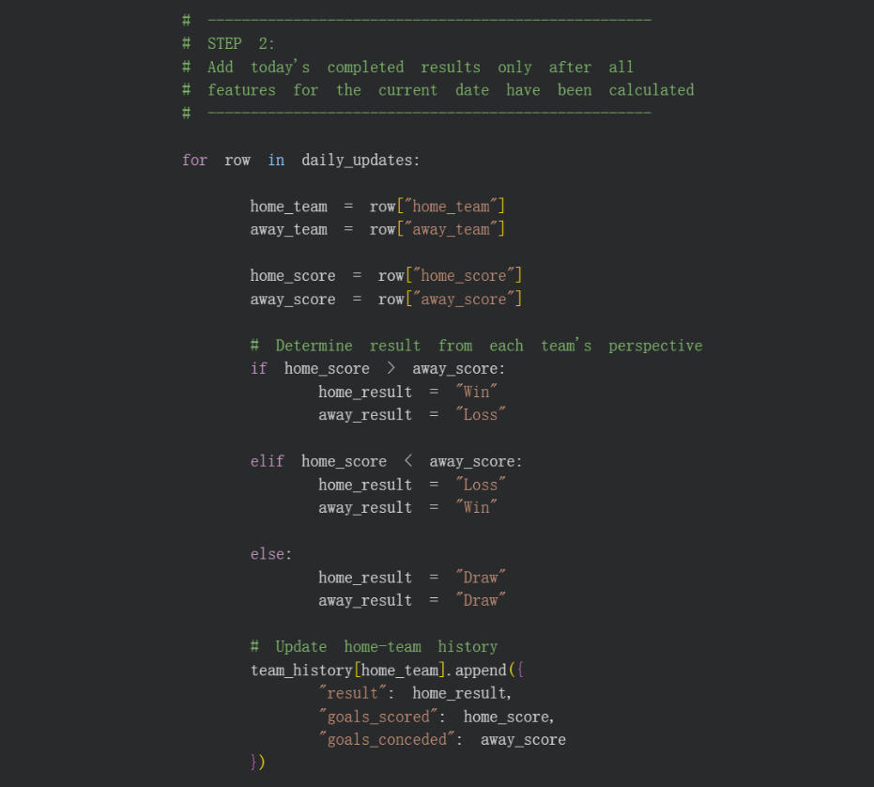
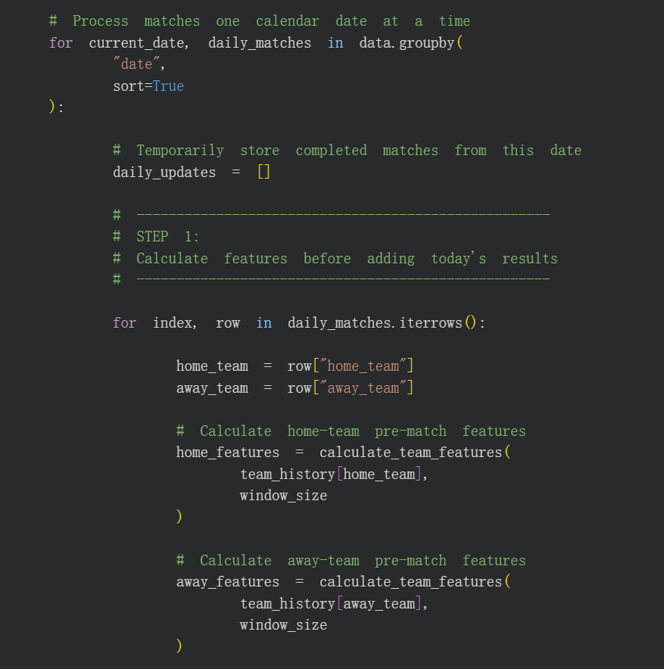
Fig7.1

7.2 Reproducibility and Clarity of Implementation
A number of steps were taken to insure the reproducibility of the experimental results.
The first one is that a fixed random state of 42 (RANDOM_STATE = 42) was used for all machine learning algorithms that include random processes. This guarantees the same behaviour of a model when executed repeatedly with the same dataset and configuration.
Secondly, the data were divided chronologically, rather than randomly. The data from roughly 80% of the historic games was used for training, and the remaining 20% for testing. The implementation also confirmed that the training and the test phase were not overlapping, thus excluding future match data in the training phase.
Thirdly, historical features were created in a chronological order. Predictor variables were computed prior to the entry of the match results in team history for matches played on the same date. This procedure avoids temporal data leakage and keeps all of the history features as information that would have been available before the match.
The same feature set, chronological split, target labels and evaluation procedure were used in all three classification models. The models were evaluated using the same metrics (Accuracy, Precision, Recall, Macro F1-Score) so that they can be compared under the same experimental conditions.
Lastly, the chosen Decision Tree model was retrained with all the available completed historical matches for the interactive prediction system. The prediction function contains the same features as the model development process, allowing the model to be used consistently in training and prediction.
These implementation practices enable to better reproduce, to make transparent, and to clarify the entire data mining process.

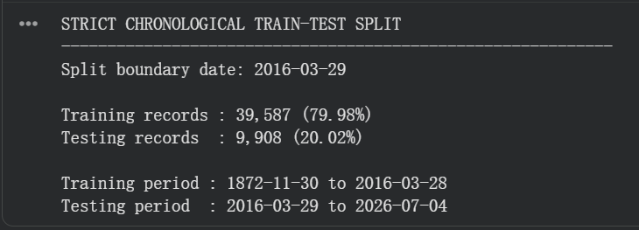

Fig7.2

8. Real-World Prediction Validation
The prediction model was finished in the last phase of the 2026 FIFA World Cup. So as a result,matches played before the completion of the model were not retrospectively treated as real-world predictions. Before the results of the matches were known, three upcoming matches were selected and predicted in order to make a practical evaluation of the completed system: England vs Argentina, France vs England, and Spain vs Argentina.
The historical data set was updated with the latest completed match data available prior to each prediction. This was a particularly crucial requirement as the prediction system is dependent on the recent performance of teams and historical statistics. Recent matches, which are still being played, may alter in-game statistics like recent win rate, draw rate, average goals, goal difference, and team experience. Thus, the model needs to be fed with a set of accurate, complete and of the most current possible data, with the added condition that no data of the match to be predicted is used in the training or generation of the features.

8.1 England vs Argentina Prediction
Before the match, the model generated the following probabilities:
- England Win: 32.4%
- Draw: 25.8%
- Argentina Win: 41.8%
The model therefore predicted Argentina to win, as Argentina had the highest predicted probability of 41.8%.
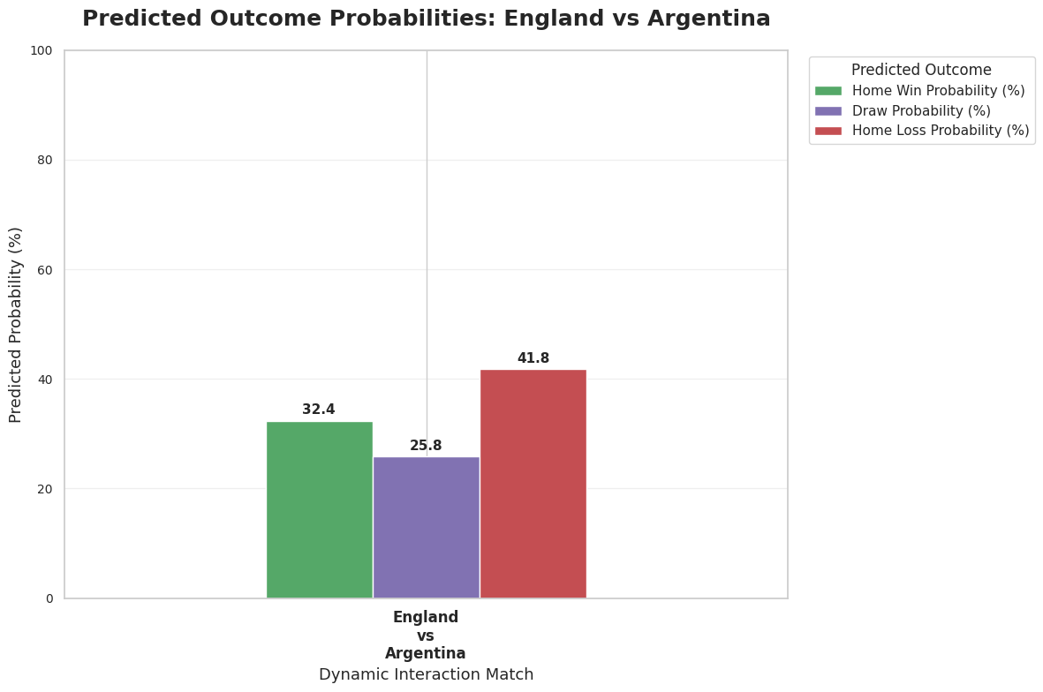
Fig8.1

8.2 France vs England Prediction
Before the match, the model generated the following probabilities:
- France Win: 18.8%
- Draw: 56.2%
- England Win: 25.0%
The model therefore predicted a Draw, with the Draw outcome receiving the highest probability of 56.2%.However, since there are no draws in the World Cup, a prediction that wins without a penalty shootout is considered basically correct.
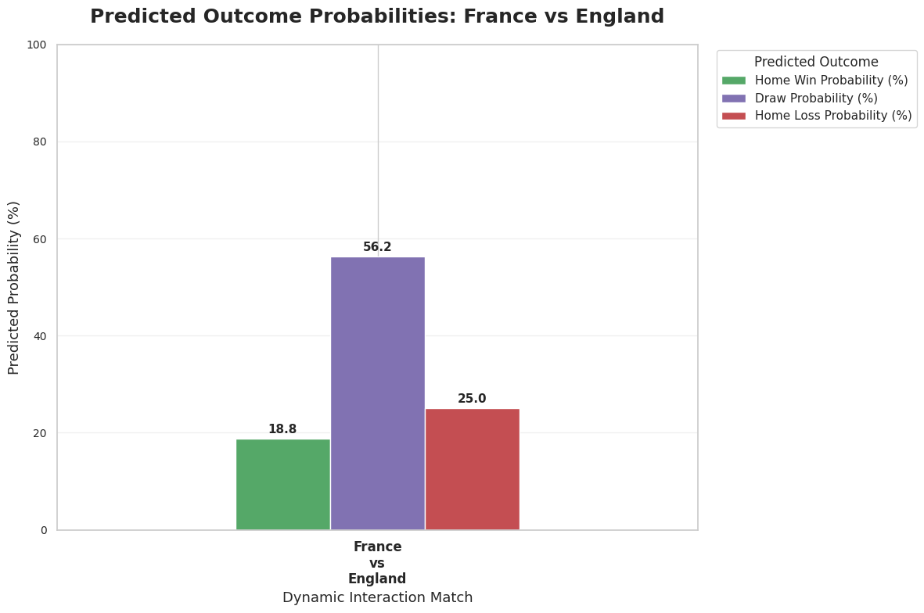
Fig8.2

8.3 Spain vs Argentina Prediction
For the FIFA World Cup Final, the model generated the following probabilities:
- Spain Win: 58.1%
- Draw: 22.6%
- Argentina Win: 19.4%
The model therefore predicted Spain to win the FIFA World Cup Final, with Spain receiving the highest probability of 58.1%.
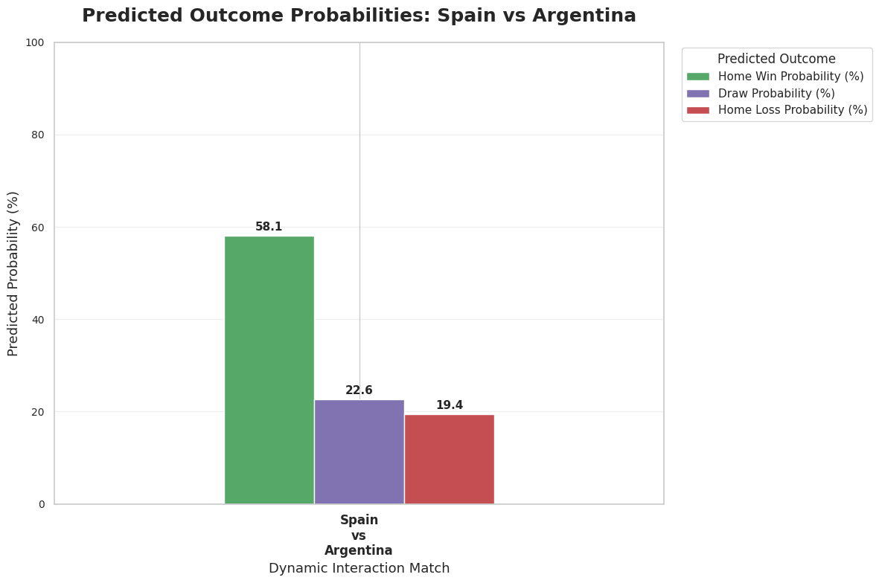
Fig8.3

8.4 Comparison with Actual Match Results
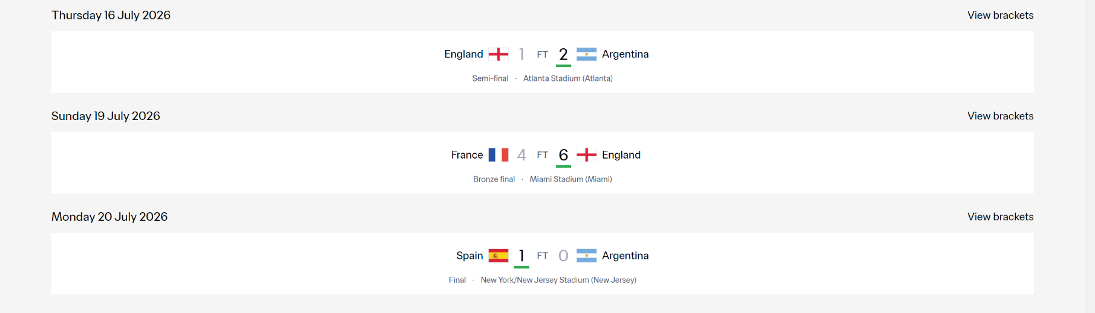
After the three matches were completed, the prospective predictions were compared with the actual FIFA World Cup results, as shown in Figure 8.4.
Fig 8.4

The comparison showed that the model successfully predicted Argentina to defeat England, with Argentina receiving the highest predicted probability of 41.8%. The actual result was England 1–2 Argentina. In the FIFA World Cup Final, the model predicted Spain to defeat Argentina with a probability of 58.1%, and the actual result was Spain 1–0 Argentina. Therefore, both winner predictions were correct.
For France vs England, the model assigned the highest probability to a Draw (56.2%), while England ultimately won the match 6–4. Therefore, this prediction was not fully correct under the three-class classification definition. However, when comparing the two winning outcomes, the model assigned a higher winning probability to England (25.0%) than France (18.8%), indicating that the model correctly identified England as the relatively stronger winning side, although it overestimated the probability of a Draw.
Overall, two of the three prospective matches were predicted correctly according to the highest-probability outcome, while the remaining prediction demonstrated a partially correct directional assessment of the two teams' winning probabilities. These real-world predictions provide additional practical evidence that the model can produce meaningful results for genuinely unseen matches.
It should also be noted that the model was completed only before these final three matches; therefore, earlier World Cup matches were not retrospectively counted as real-world predictions. The experiment further demonstrates the importance of using an accurate, complete, and up-to-date dataset, because newly completed matches directly affect recent-form and historical-performance features used for subsequent predictions.

Reference
1. Al-Bustami, A., & Ghazal, Z. (2025). From players to champions: A generalizable machine learning approach for match outcome prediction with insights from the FIFA World Cup. arXiv. https://arxiv.org/abs/2505.01902
2. Beal, R., Middleton, S. E., Norman, T. J., & Ramchurn, S. D. (2020). Combining machine learning and human experts to predict match outcomes in football: A baseline model. arXiv. https://arxiv.org/abs/2012.04380
3. FIFA. (2023). Audience report: FIFA World Cup Qatar 2022™. FIFA. https://inside.fifa.com/tournament-organisation/audience-reports/qatar-2022
Jürisoo, M. (2026). International football results from 1872 to 2026 [Data set]. Kaggle. https://www.kaggle.com/datasets/martj42/international-football-results-from-1872-to-2017
4. scikit-learn. (2019). sklearn.tree.DecisionTreeClassifier — scikit-learn 0.22.1 documentation. In Scikit-learn.org. https://scikit-learn.org/stable/modules/generated/sklearn.tree.DecisionTreeClassifier.html
5. Scikit-Learn. (2025). sklearn.ensemble.RandomForestClassifier — scikit-learn 0.20.3 Documentation. In Scikit-learn.org. https://scikit-learn.org/stable/modules/generated/sklearn.ensemble.RandomForestClassifier.html
6. scikit-learn. (2014). LogisticRegression. In Scikit-learn.org. https://scikit-learn.org/stable/modules/generated/sklearn.linear_model.LogisticRegression.html
7. scikit-learn. (2019). StandardScaler. In scikit-learn.org. https://scikit-learn.org/stable/modules/generated/sklearn.preprocessing.StandardScaler.html
8. scikit-learn. (2018). sklearn.metrics.classification_report — scikit-learn 0.20.3 documentation. In Scikit-learn.org. https://scikit-learn.org/stable/modules/generated/sklearn.metrics.classification_report.html
9. scikit-learn. (2019). sklearn.metrics.f1_score — scikit-learn 0.21.2 documentation. In Scikit-learn.org. https://scikit-learn.org/stable/modules/generated/sklearn.metrics.f1_score.html
10. (2026). Fifa.Com. https://www.fifa.com/en/tournaments/mens/worldcup/canadamexicousa2026/scores-fixtures?country=my&wtw-filter=all

APPENDIX C

ITS61504 Assignment Assessment Rubrics: Group Assignment

Group Member Names: | Report Marks | Presentation marks | Discounted marks | Total (%) | Weighted Marks (40%)
1.
2.
3.
4.
5.
6.

Feedback:

Detailed Marking Rubric for Data Mining Group Project

Criteria | Weight | Excellent (Full Marks) | Good | Satisfactory | Needs Improvement | Poor
Background and Project/Business Goal | 4% | Clear and concise background (2%) and well-defined, relevant goal (2%). | Mostly clear background and goal, minor vagueness. | Basic explanation with limited detail or clarity. | Unclear goal or vague background. | No clear background or irrelevant goal.
Data Set Description | 4% | Clearly identify data source (2%) with relevant statistics (2%). | Identifies source, some basic stats provided. | General idea of dataset with few statistics. | Missing source or incomplete statistics. | No description or unclear data explanation.
Data-Related Issues & Preprocessing | 6% | Identifies key data issues (2%) and applies thorough preprocessing (4%) with before/after examples. | Identifies most issues, preprocessing applied but lacks detail. | Some issues/preprocessing covered, with limited examples. | General description but lacks specifics or examples. | Data issues not discussed, preprocessing unclear or missing.
Data Mining Techniques & Justification | 6% | Relevant techniques described (2%) and strongly justified (4%) based on data/project. | Good technique choice and justification with minor gaps. | Basic explanation and weak justification. | Unclear method selection or vague justification. | Poor or no description of techniques.
Model Validation | 4% | Clearly explains how model was validated, with metrics used (4%). | Mostly clear explanation with some metrics shown. | Basic explanation of validation lacks metric clarity. | Vague or brief validation discussion. | No validation or completely unclear.
Conclusion & Improvements | 2% | Logical conclusions drawn (1%) and reasonable improvement ideas (1%). | Good observations, basic improvement suggestions. | General conclusions with limited future insight. | Weak observations or improvements. | No clear conclusion or improvement discussion.
Project Demo (Presentation) and Report formatting | 14% | - Preprocessing demo (6%): Clear, complete process shown  - Data mining demo (8%): Complete implementation and insights shown | Mostly complete demos with small gaps or unclear areas. | Demos shown but rushed or not well explained. | Demo lacks depth or completeness. | No working demo or poorly presented.

Additional Guidance for Students:
- Collaboration: Ensure balanced participation from all group members. Clearly document each member’s contributions.
- Ethics: Address bias, transparency, and responsible use of predictive models.
- Research Quality: Use reputable sources such as academic journals and industry reports. Avoid unverified or low-quality sources.
- Proofreading: Carefully proofread your report for clarity and coherence. Ensure arguments are logical and well-supported.

